**Working example of Continuous integration and Continuous delivery**

1. First, the development starts with the dev environment as in real time project.
2. Let’s create a feature branch in Dev environment and start creating a simple pipeline with ‘Wait Activity’

1. Created trigger_2 which is tumbling window trigger which is dependent on trigger_1, which can be useful in testing our pre-deployment and post-deployment script.

1. The pipeline changes are auto saved after attaching the trigger to the test pipeline.

1. Let’s create a pull request, and approve the change to be deployed in Dev, Test environments

1. Pull request has been approved and merged the changes to the main branch which starts our build pipeline,

1. Build pipeline publishes the ARM templates to the release pipeline which deploys the changes in Dev and Test environments continuously.

Dev Completed:

Test Completed:

1. Changes implemented in Test Environment and now the pipeline waits for my approval to be deployed in production.

**Prod change approved and deployment starts:**

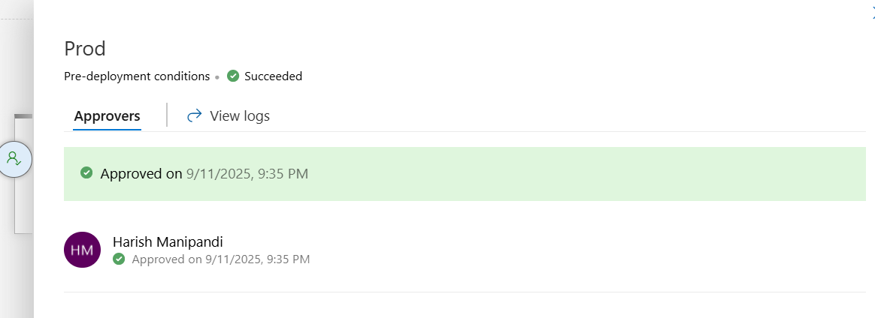

**Changes are now deployed to the prod.**

